**MINI PROJECT**

**(2020-2021)**

**Internal Conflict Management System**

**MID-TERM REPORT**



**Institute of Engineering & Technology**

**Shraddha Gupta (181500686)**

**Danish Ali (181500200)**

**Harshita Jaiswals (181500262)**

**Ritika Singh (181500584)**

**Akanksha Gupta (181500050)**

***Supervised By*: -**

**Mr. Amir khan**

Technical Trainer

**Department of Computer Engineering & Applications**

**Contents**

**1.Abstract 3**

**2.Introduction 4**

**3.Hardware and Software Requirements 6**

**4. Objectives 7**

**5.Fuctional Specification 8**

**6.Existing System 9**

**7.Use of Project 10**

**8.Future Scope 12**

**9. Implementation Details with Screenshots 13**

**10. Mess Webpage with Screenshots 14**

**10. Progress till Date & The Remaining work 20**

**11. References 21**

**Abstract**

Design and implementation of Internal Conflict Management System based on the web development in this project. A user-friendly conflict management is built using HTML, CSS, etc to solve the conflicts(complaints) regarding hostels, mess and administration buildings. Basically, this will help students as well as staffs of the university.

**Introduction**

A **consumer complaint** or **customer complaint** is "an expression of dissatisfaction on a consumer's behalf to a responsible party". It can also be described in a positive sense as a report from a consumer providing documentation about a problem with a product or service. In fact, some modern business consultants urge businesses to view customer complaints as a gift.

Consumer complaints are usually informal complaints directly addressed to a company or public service provider, and most consumers manage to resolve problems with products and services but it sometimes requires persistence.

An *instrumental* complaint is a complaint made to a person or organization that could take some action and bring about a specific remedy. An *expressive* complaint is a complaint made for the purpose of expressing feelings, without any realistic chance of anything being done. Most online complaints are expressive complaints.

Internal Conflict Management System is a web-based application that is designed to make the process of resolving complaints(conflict) made by students in the university environment easy. It can be used to deliver information faster without any redundancy.

Using the software, the university management would be able to maintain an effective, timely and equitable complaints handling system that is easily accessible by the students. Internal Conflict (complaints) Management System in the university helps to resolve a lot of problems or issue like mess, library, hostel, academy, etc for a university growth.

This project identifies a range of options that can be used to manage university complaints.

If a student feels uncomfortable about having their Complaint with informally, or has not been able to resolve it informally, they can choose to have their complaint with formally using this internal conflict management system. All formal complaints must be made by the student, their authorised representative.

**Hardware and Software specification**

**Software Specification:**

* Language Used : Python
* Database : CSS, HTML
* User Interface Design : Virtual studio code, Sublime

Text Editor

* Web Browser : Google Chrome

**Hardware Requirements:**

* Processor : 64-bit, four-core, 2.5 GHz minimum

per core

* Operating System : Windows 10,
* RAM : 8GB
* Hard disk : 1024 GB
* Display : 1280 x 768 screen resolution

**Objectives**

The objective of the internal conflict management system is to make complaints easier to coordinate, monitor, track and resolve, and to provide company with an effective tool to identify and target problem areas, monitor complaints handling performances and make business improvements.

The system registers the complaints of the student through an integrated interface whenever a student has got any complaint related to the campus, regarding library, labs or college infrastructure then they can make online complaints. Their complaint are being taken care by the respective authorities. It also provide an online ways to solving the problems faced by the public by saving time and eradicate corruption, and the ability of providing many of the reports on the system and to facilate the process of submitting a complaint.

An effective internal conflict resolution process or system in your business or organisation can prevent recurring conflict escalation and puts in place effective procedures for resolving conflict that does arise it leads to many benefits, such as accomplishing goals and strengthening relationship. conflict management system enables organisations to proactively review the way conflict arises and improve how it is handled in the workplace. The aim of this system is to enhance learning and group outcomes including effectiveness or performance in an organizational.

**FUNCTIONAL SPECIFICATION**

Conflicts are natural in all walks of daily life – both at workplace and home. Thus, conflict is ever present and both charming and maddening. But conflict is a complex and big subject. There are many sources of conflict. Conflict occurs when individuals or groups are not obtaining what they need or want and are seeking their own self-interest.

Sometimes the individual is not aware of the need and unconsciously starts to act out. Other times, the individual is very aware of what he or she wants and actively works at achieving the goal. It would be better to identify conflict at an early stage and come to an understanding.

The concept of conflict is controversial. Psychologists and sociologists have given different meanings. It is being defined as a process by few, an obstructive behaviour, and goal incompatibility by others. Conflict can be expressed as:

Conflict is a process, where perception (real or otherwise) leads to disruption of desirable state of harmony and stability in an interdependent world.

**Existing System**

For the past few years, the numbers of educational institutions are increasing rapidly.

Thereby the numbers of hostels are increasing for the accommodation of the students studying in this institution. Internal conflict management system deals with complaints generated by public and resolves the problem of every individual. We can improve the efficiency of the system, thus overcome the following drawbacks of the existing system.

* More human error.
* More strength and strain of manual labour needed
* Repetition of the same procedure.
* Low security
* Data redundancy
* Difficult to handle
* Difficult to update data
* Record keeping is difficult
* Backup data can be easily generated

**USe of the project**

The objective of the internal conflict management system is to make complaints easier to coordinate, monitor, track and resolve, and to provide company with an effective tool to identify and target problem areas, monitor complaints handling performances and make business improvements.

The system registers the complaints of the student through an integrated interface whenever a student has got any complaint related to the campus, regarding library, labs or college infrastructure then they can make online complaints. Their complaint is being taken care by the respective authorities.

It also provides an online way to solving the problems faced by the public by saving time and eradicate corruption, and the ability of providing many of the reports on the system and to facilate the process of submitting a complaint.

An effective internal conflict resolution process or system in your business or organisation can prevent recurring conflict escalation and puts in place effective procedures for resolving conflict that does arise it leads to many benefits, such as accomplishing goals and strengthening relationship. conflict management system enables organisations to proactively review the way conflict arises and improve how it is handled in the workplace.

The aim of this system is to enhance learning and group outcomes including effectiveness or performance in an organizational.

**FUTURE SCOPE**

This project has a very vast scope in future and can be easily implemented under various situations. Project can be updated in near future as and when requirement for the same arises, as it is very flexible in terms of expansion. We can add new features as and when we require.

The following are the future scope for the project.

1. Receiving student complaints and provides them their complaint status.
2. Higher speed of receiving complaints.
3. Distribution of related complaints among different departments, etc.

**Implementation details with Screenshots**

Feedback form Screenshot

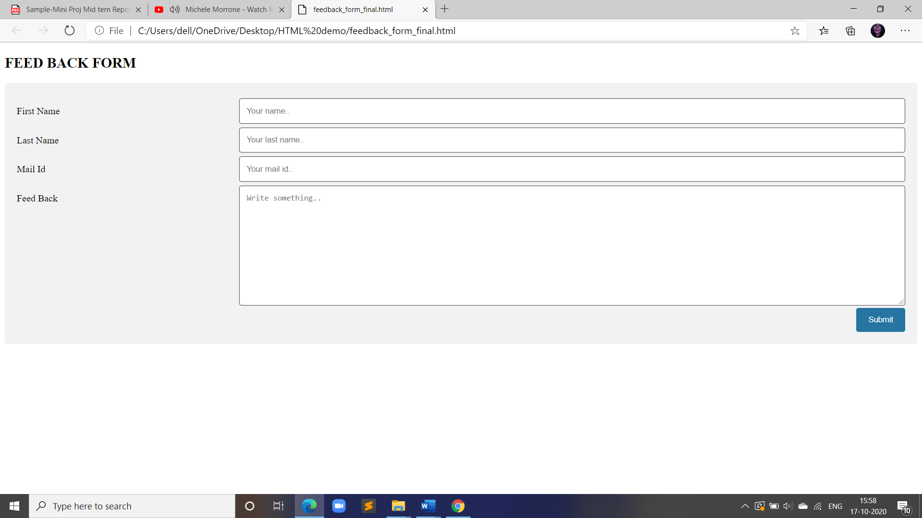

Mess Web Page Screenshots

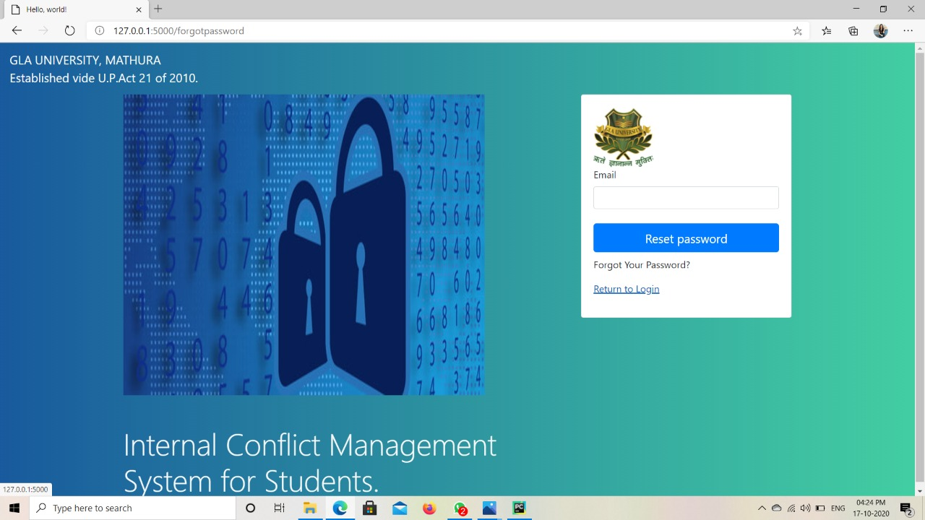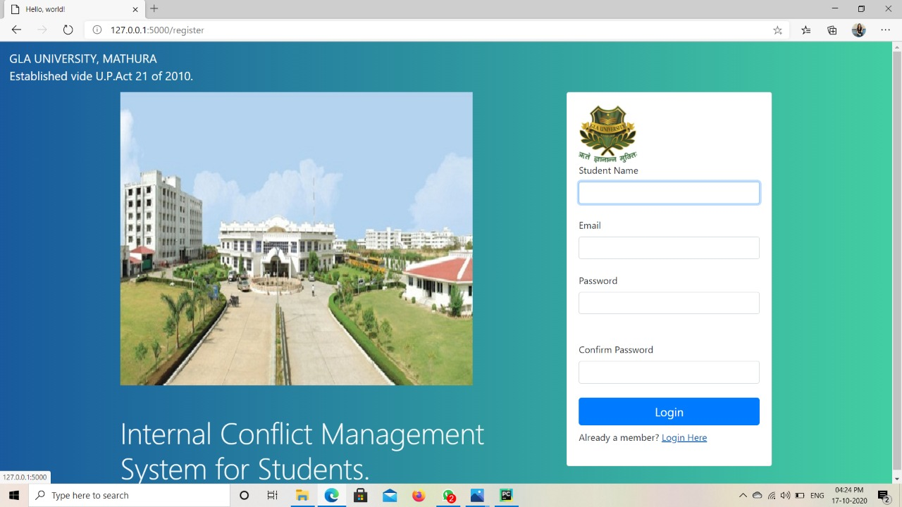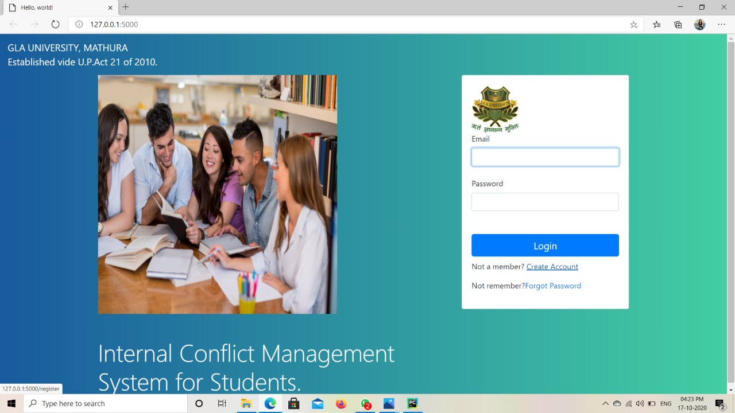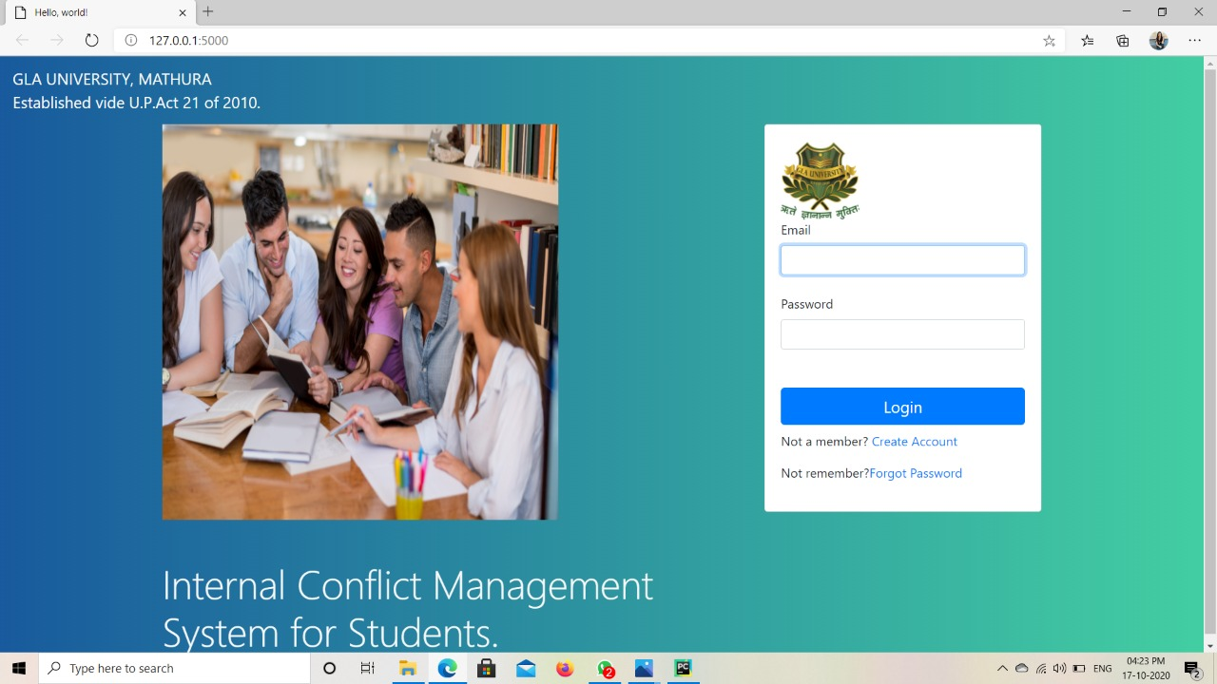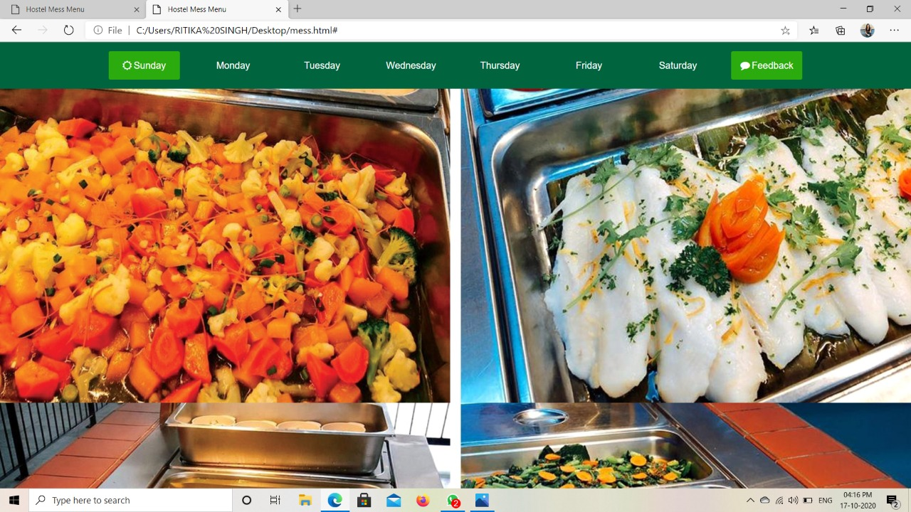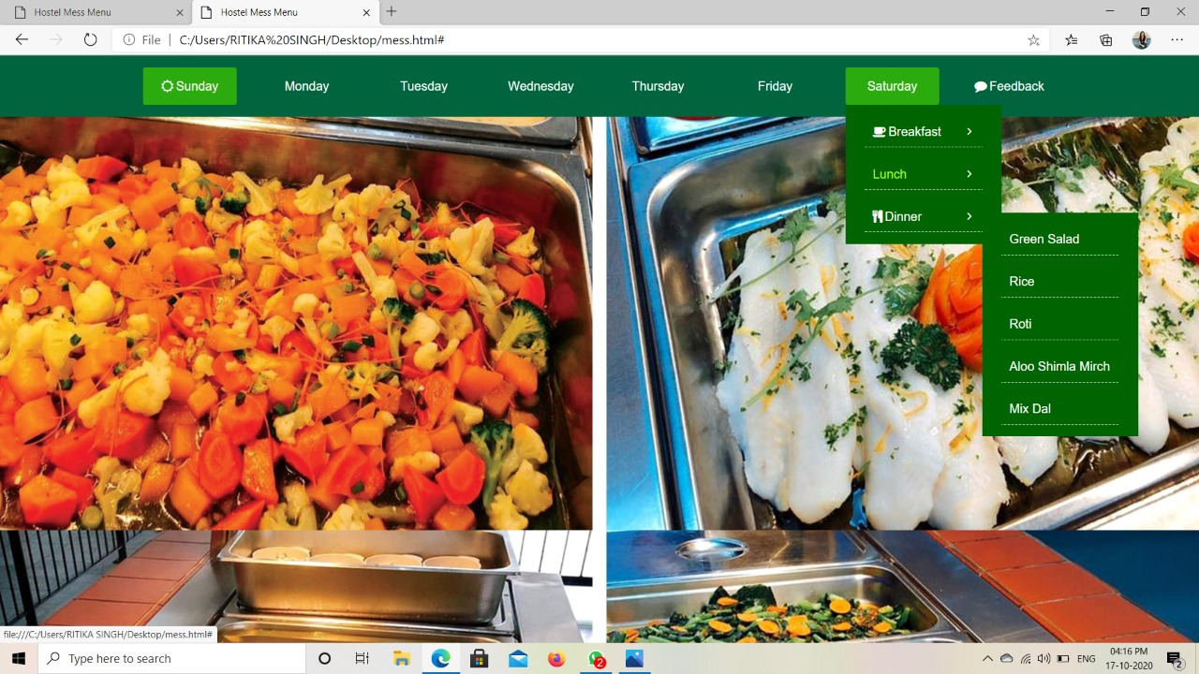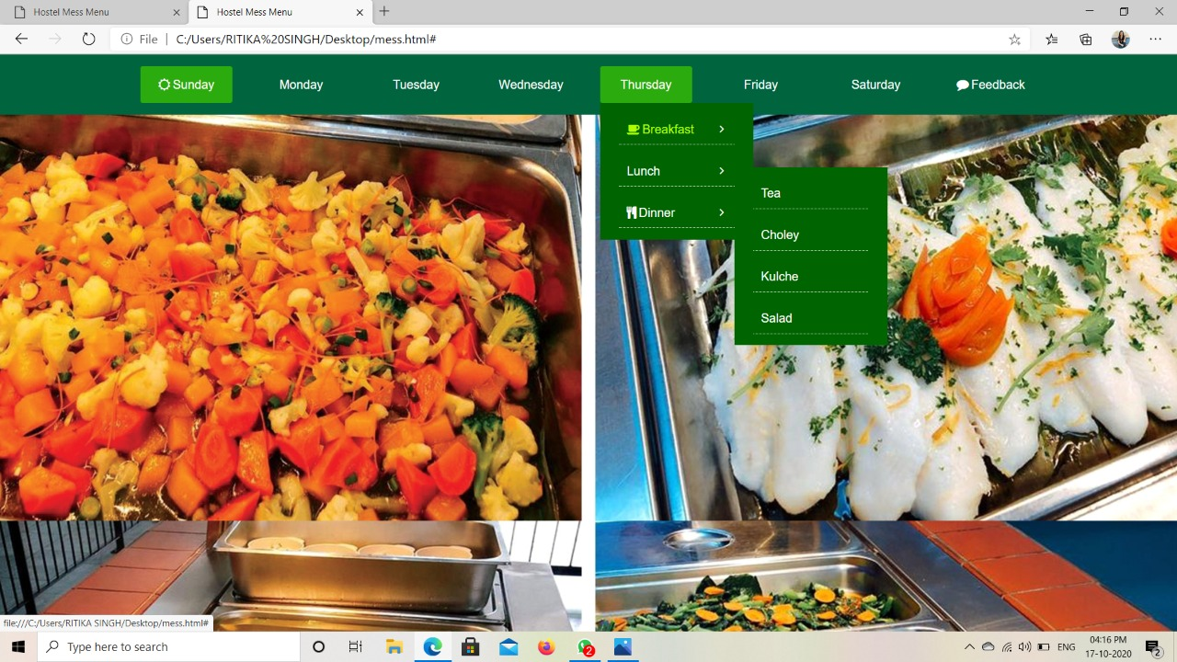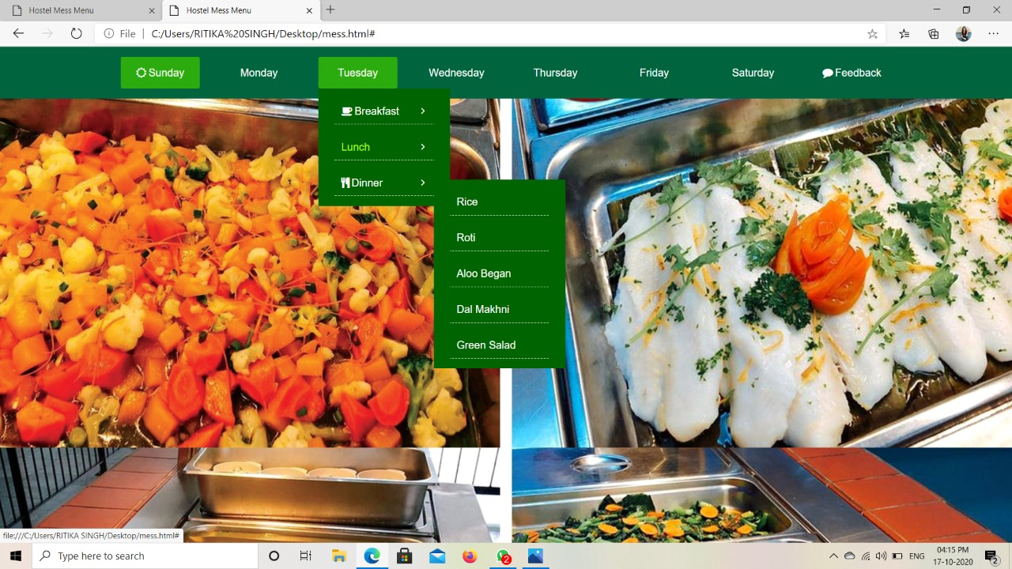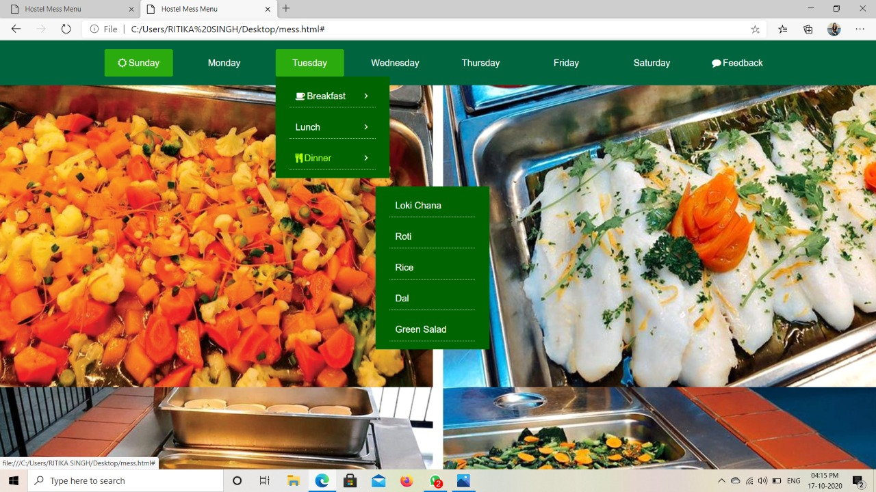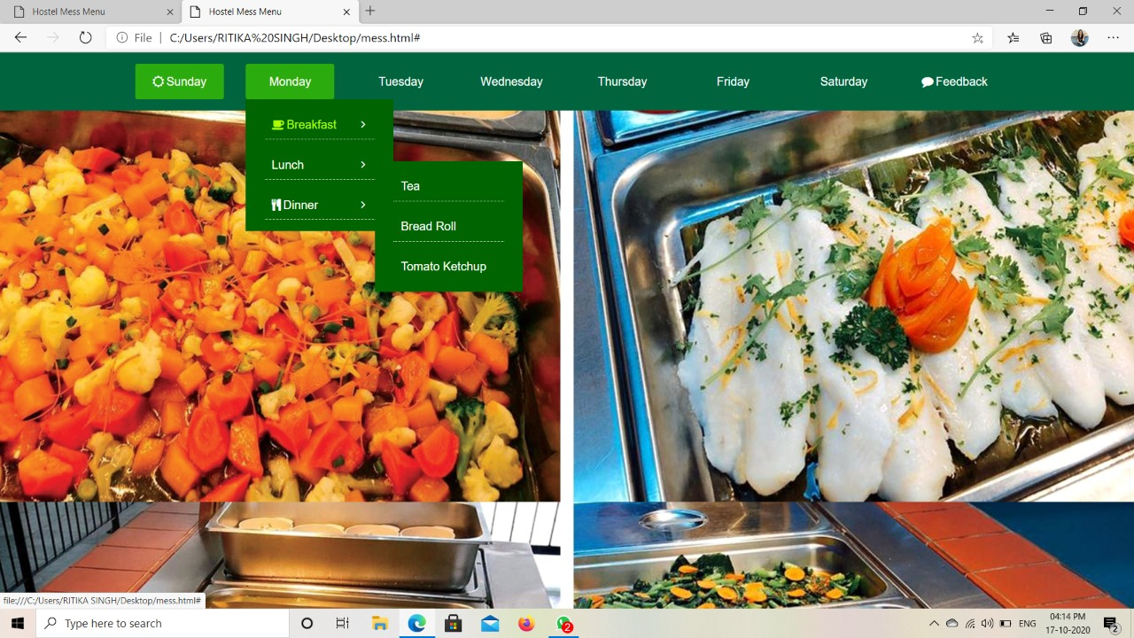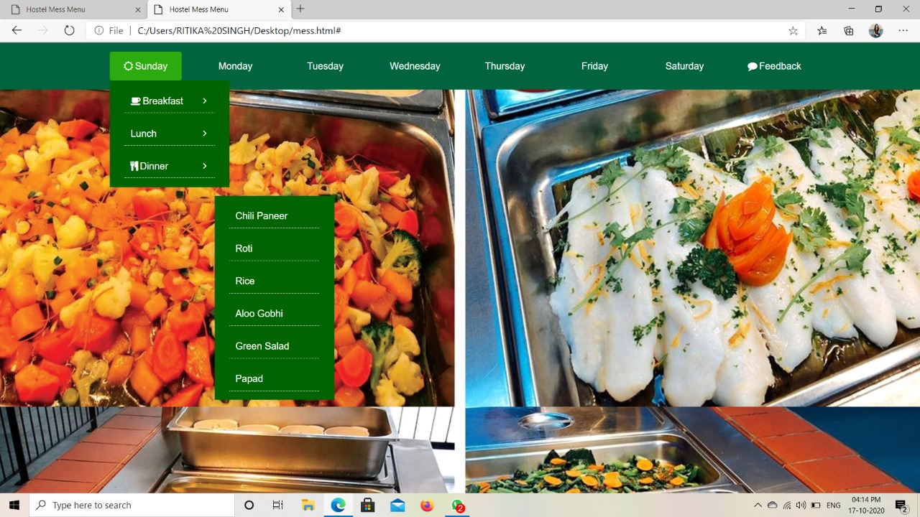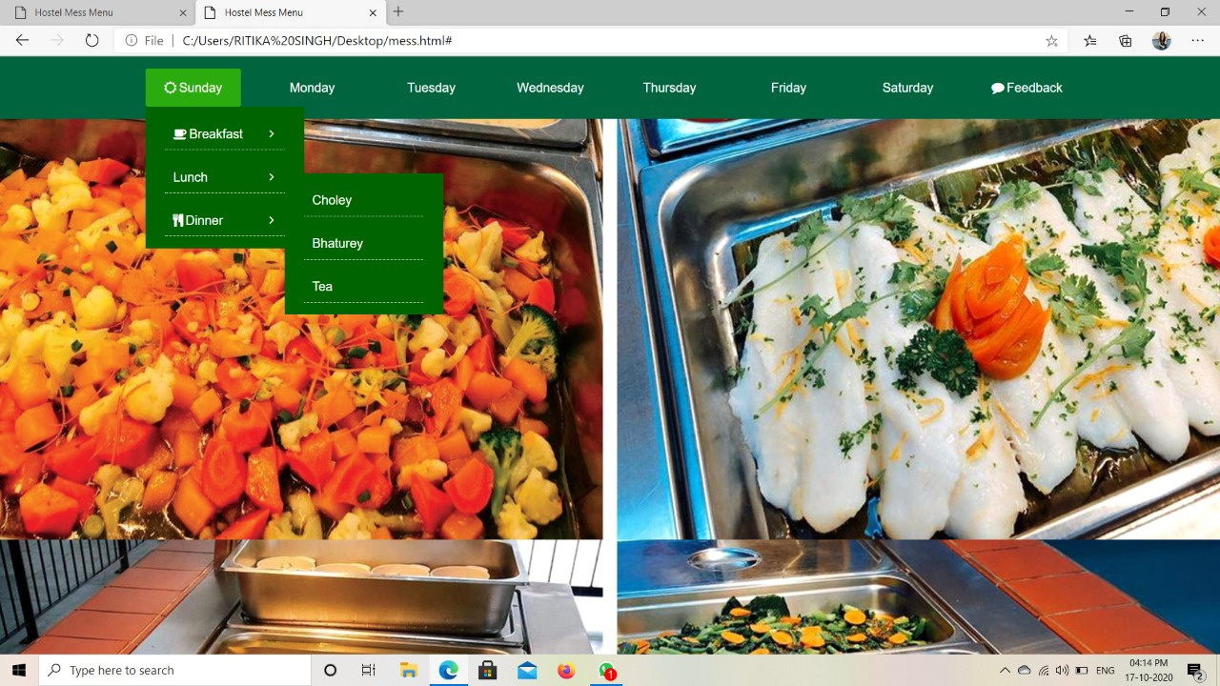

**Progress till Date & The Remaining work**

65% of the work is completed up to date and for the further work history the above screenshots are shown.

Framing work, administration building work and hostel work are still left which will take probably 2 weeks to be fully and functionally completed.

**References**

[**https://www.w3schools.com/html/**](https://www.w3schools.com/html/)

[**https://www.w3schools.com/css/**](https://www.w3schools.com/css/)

[**https://en.wikipedia.org/wiki/Django_(web_framework)**](https://en.wikipedia.org/wiki/Django_(web_framework))